Software Modeling Design Assignment 2
SmartSummerAgricultureSystem (SSAS)
UML Diagrams
Name: MUTANGANA Joseph ID: 29061

1. Use case diagram
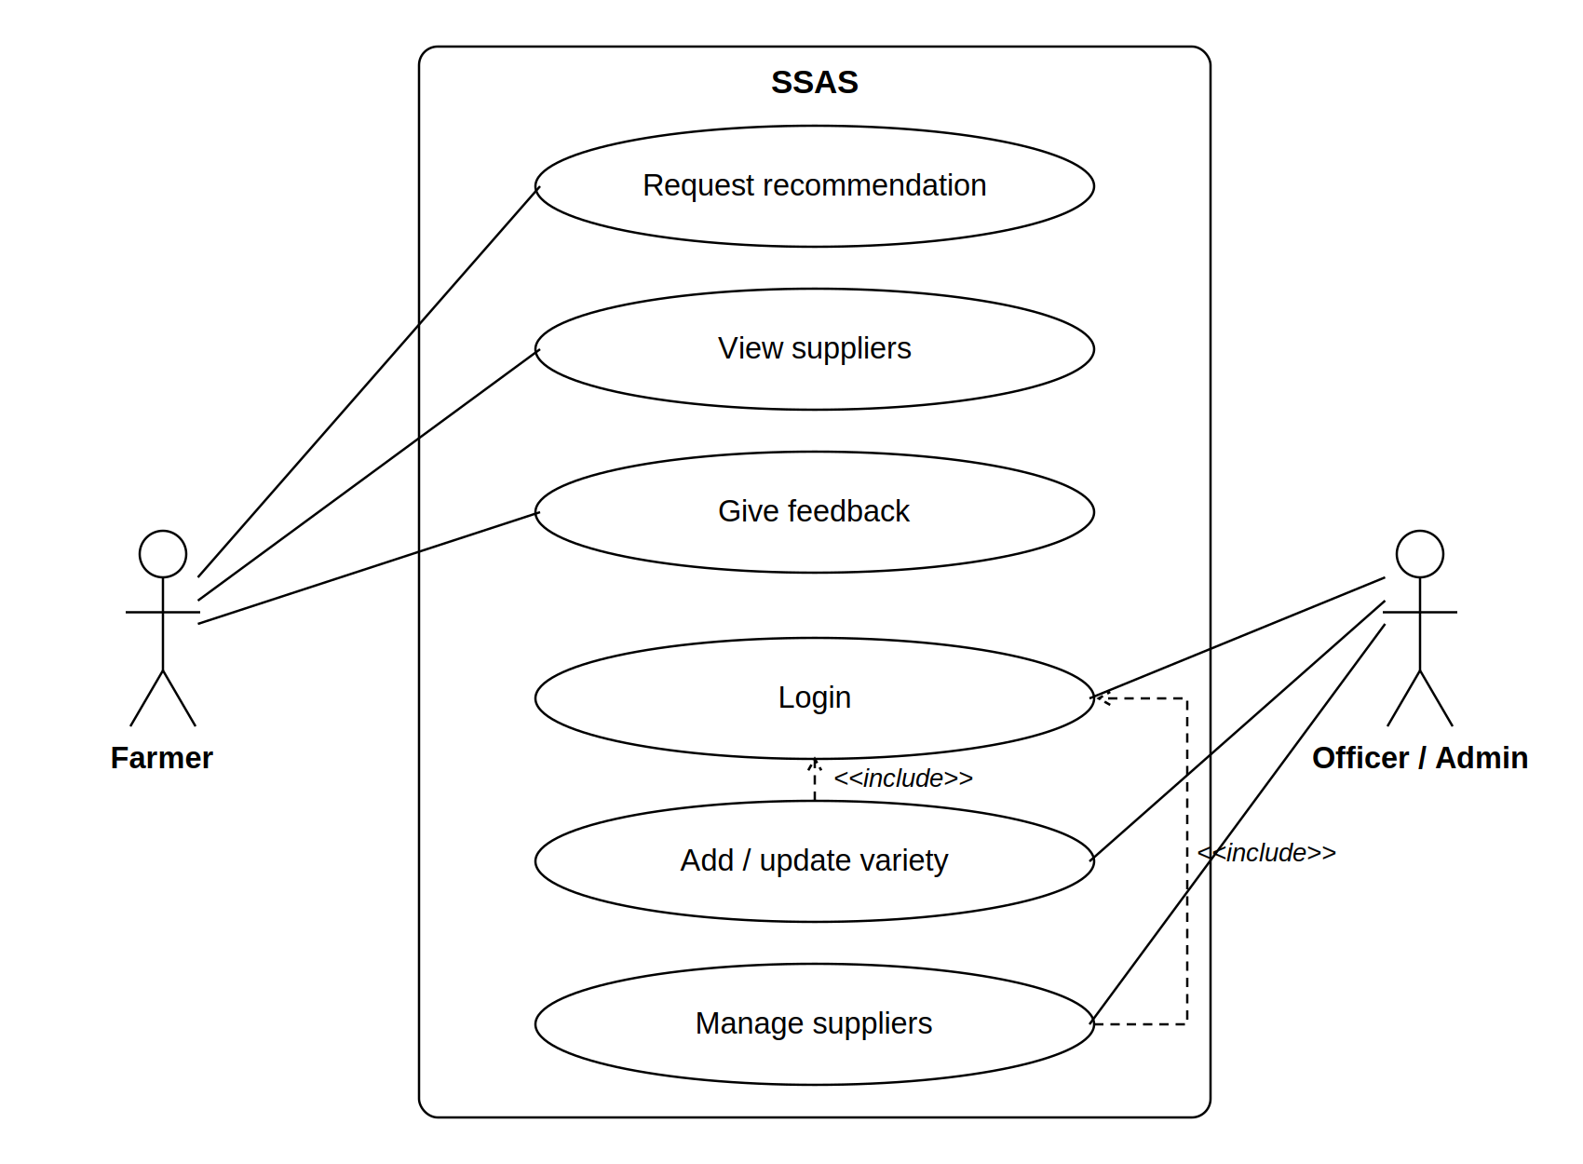
2. Sequence diagram
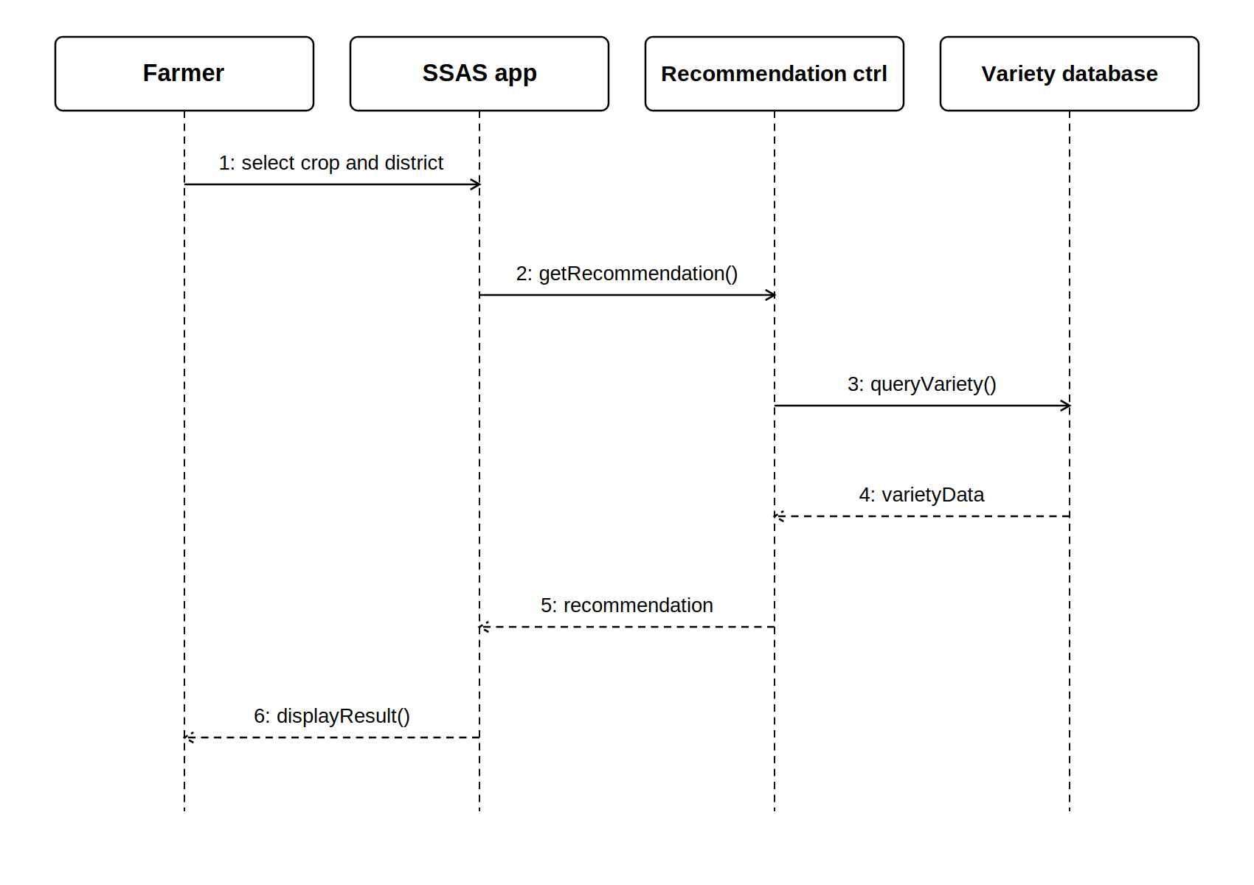

3. Class diagram
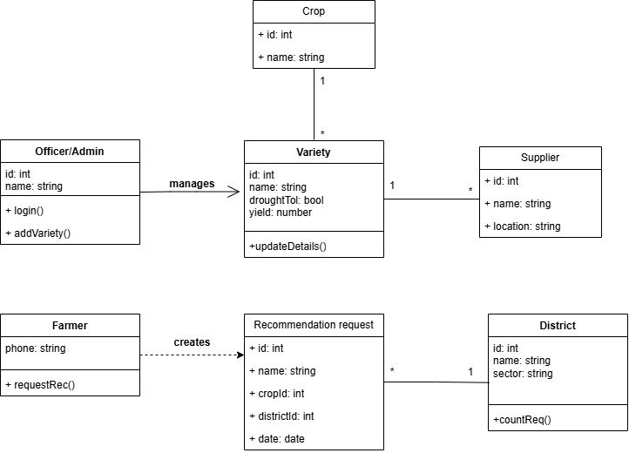
4. Activity diagram
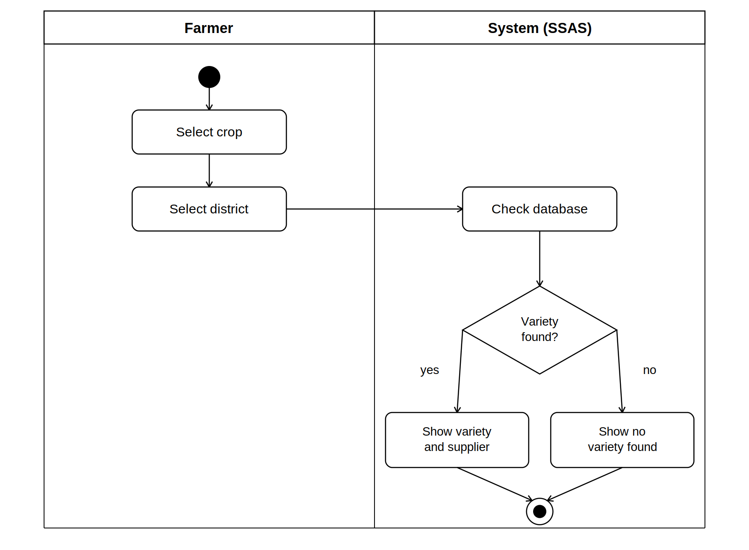

5. State diagram
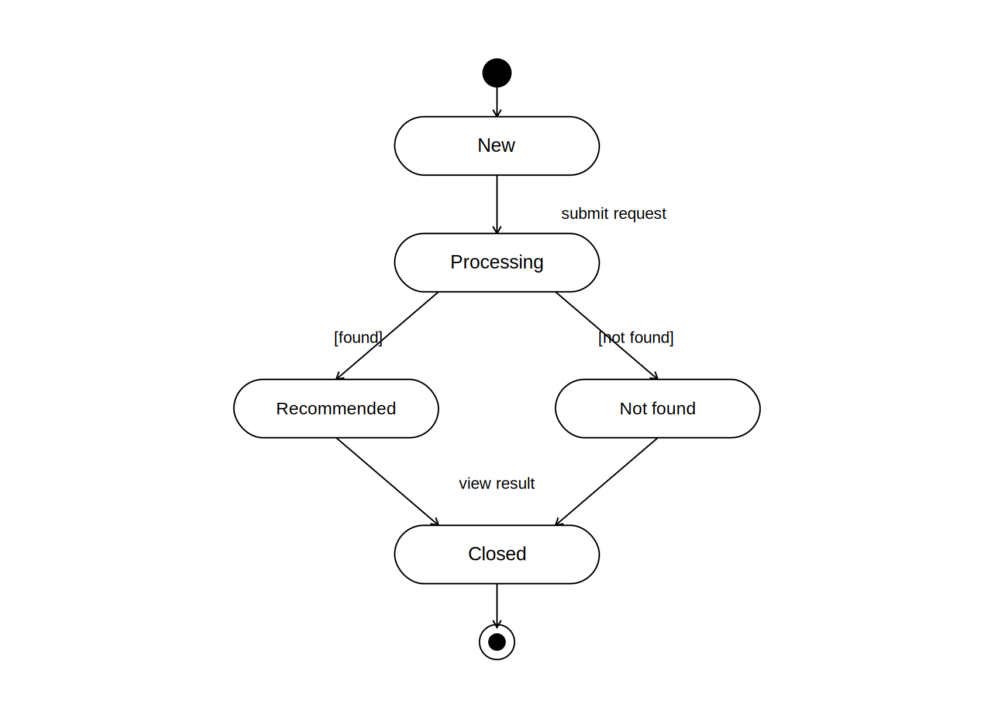
Su

